Retractable roof/enclosure questionnaire:

Title | Details
Type of Roof |  | Top roof |  |  | 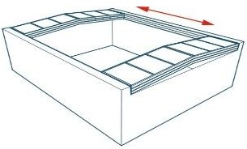 |  |  |  |  |  | 
Type of Roof |  | Partial retractable enclosure |  |  | 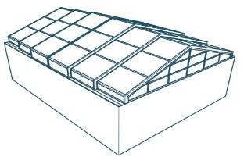 |  |  |  |  |  | NA
Type of Roof |  | Complete retractable enclosure |  |  | 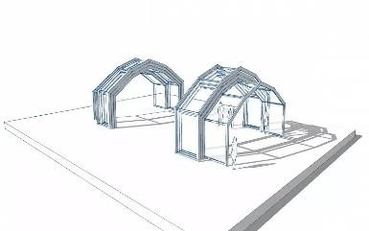 |  |  |  |  |  | NA
Operation |  | Automatic |  |  |  |  |  | Manual
Operation |  |  | Remote | Pendant |  |  |  | Fixed Structure with roof lights air ventilators & AC
Operation |  |  | NA | NA
Clear opening area  (Cut out area) |  | Dimensions |  |  |  | Inner |  |  |  | Outer
Clear opening area  (Cut out area) |  | Length |  |  |  | Basketball- 29.60 Meters  Tennis- 30.80 Meters |  |  |  | Basketball- 1 Meter  Tennis- 1Meter
Clear opening area  (Cut out area) |  | Width |  |  |  | Basketball- 13.60 Meters  Tennis- 19.80 Meters |  |  |  | Basketball- 1 Meter  Tennis- 1Meter
Clear opening area  (Cut out area) |  | Height |  |  |  | Basketball- 7 Meters  Tennis- 9 Meters
Opening option |  | Centre opening |  |  |  |  |  |  | One side
Opening option |  | NA |  |  |  |  |  |  | NA
Stacking place available (outside the cut out) |  | If Yes, how much? |  |  |  |  |  |  | NO
Stacking place available (outside the cut out) |  | 15 X 15 Feet

Supporting structure present at site |  | Yes |  |  | No
Supporting structure present at site |  |  |  |  |  | Client |  | NIHVA
 |  |  |  |  |  | Not available
Colour specification Aluminium profile |  | Powder coat code (RAL)
Polycarbonate  sheet option |  | Clear | Embossed |  |  |  | Tinted
No. Of expected cycles in a day
AMC required (Tenure) |  | Years |  | Visits/year
Wind pressure at site | Moderate
Additional remark
CAD  file/Layout plan | Attached in the Mail
Attached Site photographs

